Java Documentation Comments Page 1 of 4

https://www.tutorialspoint.com/java/java_documentation.htm Copyright © tutorialspoint.com

The Java language supports three types of comments −
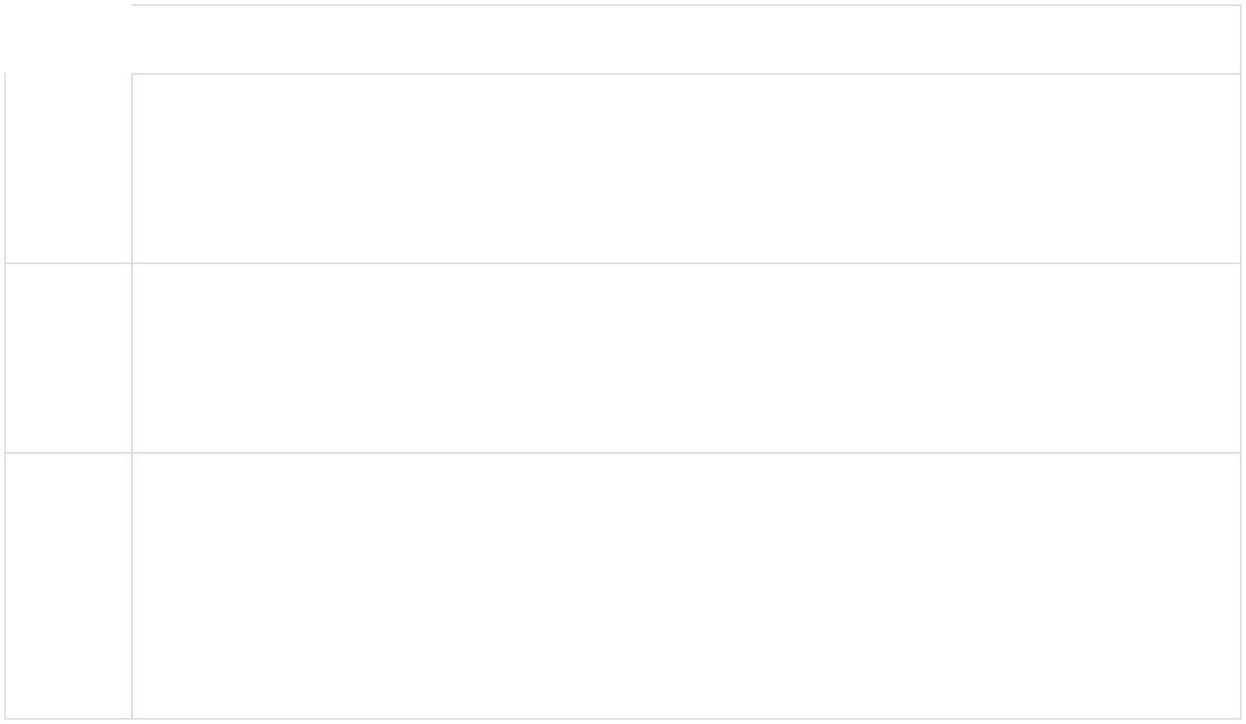

Sr.No. | Comment & Description

1

/* text */

The compiler ignores everything from /* to */.

2

//text

The compiler ignores everything from // to the end of the line.

3

/** documentation */

This is a documentation comment and in general its called doc comment. The JDK javadoc tool uses doc comments when preparing automatically generated documentation.

This chapter is all about explaining Javadoc. We will see how we can make use of Javadoc to generate useful documentation for Java code.

What is Javadoc?

Javadoc is a tool which comes with JDK and it is used for generating Java code documentation in HTML format from Java source code, which requires documentation in a predefined format.

Following is a simple example where the lines inside /*….*/ are Java multi-line comments. Similarly,

the line which preceeds // is Java single-line comment.

Example

/**

- The HelloWorld program implements an application that

- simply displays "Hello World!" to the standard output.

- @author Zara Ali

- @version 1.0

- @since 2014-03-31

*/

public class HelloWorld {

public static void main(String[] args) {

/* Prints Hello, World! on standard output.

System.out.println("Hello World!");

}

}

https://www.tutorialspoint.com/cgi-bin/printpage.cgi 29/3/2018

Java Documentation Comments Page 2 of 4

You can include required HTML tags inside the description part. For instance, the following example makes use of <h1>....</h1> for heading and <p> has been used for creating paragraph break −

Example

/**

- <h1>Hello, World!</h1>

- The HelloWorld program implements an application that

- simply displays "Hello World!" to the standard output.

- <p>

- Giving proper comments in your program makes it more

- user friendly and it is assumed as a high quality code.

- @author Zara Ali

- @version 1.0

- @since 2014-03-31

*/

public class HelloWorld {

public static void main(String[] args) {

/* Prints Hello, World! on standard output.

System.out.println("Hello World!");

}

}

The javadoc Tags

The javadoc tool recognizes the following tags −
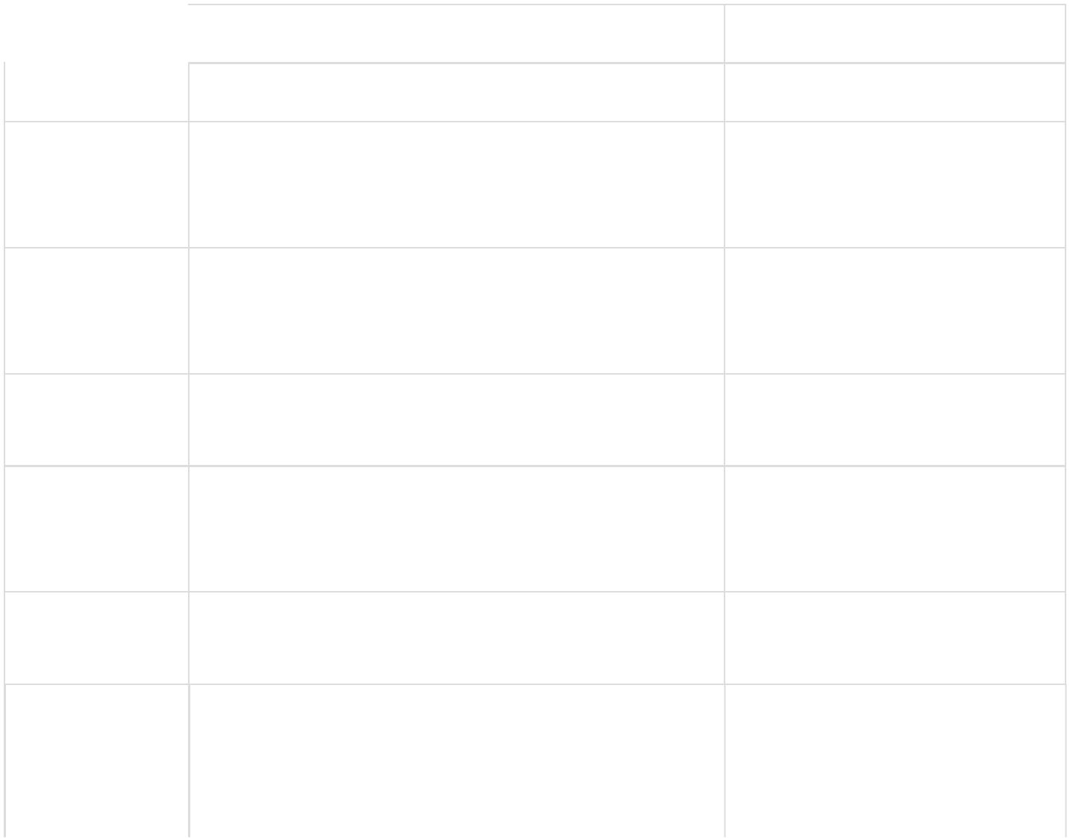

Tag | Description
@author | Adds the author of a class.
{@code} | Displays text in code font without interpreting
 | the text as HTML markup or nested javadoc
 | tags.
{@docRoot} | Represents the relative path to the generated
 | document's root directory from any generated
 | page.
@deprecated | Adds a comment indicating that this API should
 | no longer be used.
@exception | Adds a Throws subheading to the generated
 | documentation, with the classname and
 | description text.
{@inheritDoc} | Inherits a comment from the nearest
 | inheritable class or implementable interface.
{@link} | Inserts an in-line link with the visible text label
 | that points to the documentation for the
 | specified package, class, or member name of a
 | referenced class.

Syntax

@author name-text

{@code text}

{@docRoot}

@deprecated deprecatedtext

@exception class-name description

Inherits a comment from the immediate surperclass.

{@link

package.class#member label}

https://www.tutorialspoint.com/cgi-bin/printpage.cgi 29/3/2018

Java Documentation Comments Page 3 of 4


{@linkplain} | Identical to {@link}, except the link's label is
 | displayed in plain text than code font.
@param | Adds a parameter with the specified parameter-
 | name followed by the specified description to
 | the "Parameters" section.
@return | Adds a "Returns" section with the description
 | text.
@see | Adds a "See Also" heading with a link or text
 | entry that points to reference.
@serial | Used in the doc comment for a default
 | serializable field.
@serialData | Documents the data written by the writeObject
 | or writeExternal methods.
@serialField | Documents an ObjectStreamField component.
@since | Adds a "Since" heading with the specified since-
 | text to the generated documentation.
@throws | The @throws and @exception tags are
 | synonyms.
{@value} | When {@value} is used in the doc comment of a
 | static field, it displays the value of that constant.
@version | Adds a "Version" subheading with the specified
 | version-text to the generated docs when the
 | -version option is used.

{@linkplain

package.class#member label}

@param parameter-name description

@return description

@see reference

@serial field-description | include | exclude

@serialData data-description

@serialField field-name field-type field-description

@since release

@throws class-name description

{@value package.class#field}

@version version-text

Example

Following program uses few of the important tags available for documentation comments. You can make use of other tags based on your requirements.

The documentation about the AddNum class will be produced in HTML file AddNum.html but at the same time a master file with a name index.html will also be created.


import java.io.*;

/**

- <h1>Add Two Numbers!</h1>

- The AddNum program implements an application that

- simply adds two given integer numbers and Prints

- the output on the screen.

- <p>

- <b>Note:</b> Giving proper comments in your program makes it more

- user friendly and it is assumed as a high quality code.

*

https://www.tutorialspoint.com/cgi-bin/printpage.cgi 29/3/2018

Java Documentation Comments Page 4 of 4

- @author Zara Ali

- @version 1.0

- @since 2014-03-31 */
public class AddNum { /**
  - This method is used to add two integers. This is

  - a the simplest form of a class method, just to

  - show the usage of various javadoc Tags.

  - @param numA This is the first paramter to addNum method

  - @param numB This is the second parameter to addNum method

  - @return int This returns sum of numA and numB.

*/

public int addNum(int numA, int numB) {

return numA + numB;

}

/**

- This is the main method which makes use of addNum method.

- @param args Unused.

- @return Nothing.

- @exception IOException On input error.

- @see IOException

*/

public static void main(String args[]) throws IOException { AddNum obj = new AddNum();

int sum = obj.addNum(10, 20);

System.out.println("Sum of 10 and 20 is :" + sum);

}

}

Now, process the above AddNum.java file using javadoc utility as follows −

$ javadoc AddNum.java

Loading source file AddNum.java...

Constructing Javadoc information...

Standard Doclet version 1.7.0_51

Building tree for all the packages and classes...

Generating /AddNum.html...

AddNum.java:36: warning - @return tag cannot be used in method with void return

type.

Generating /package-frame.html...

Generating /package-summary.html...

Generating /package-tree.html...

Generating /constant-values.html...

Building index for all the packages and classes...

Generating /overview-tree.html...

Generating /index-all.html...

Generating /deprecated-list.html...

Building index for all classes...

Generating /allclasses-frame.html...

Generating /allclasses-noframe.html...

Generating /index.html...

Generating /help-doc.html...

- warning

$

You can check all the generated documentation here − AddNum. If you are using JDK 1.7 then javadoc does not generate a great stylesheet.css, so we suggest to download and use standard stylesheet from https://docs.oracle.com/javase/7/docs/api/stylesheet.css

https://www.tutorialspoint.com/cgi-bin/printpage.cgi 29/3/2018

